MSBA 250 — Applied Business Analytics
University of the Pacific
Spring 2024
Assignment 4
Due: Saturday April 6, 2024

Instructions:

This problem set has 3 questions. The full credit is 20.

Problem 1 (7 points):

Please find the EXCEL file named “Employee Retention,” and please find the determinants (either positive or negative) for employee retention (measured by YearsPLE).

- Please first code the categorical variables into numerical variables. 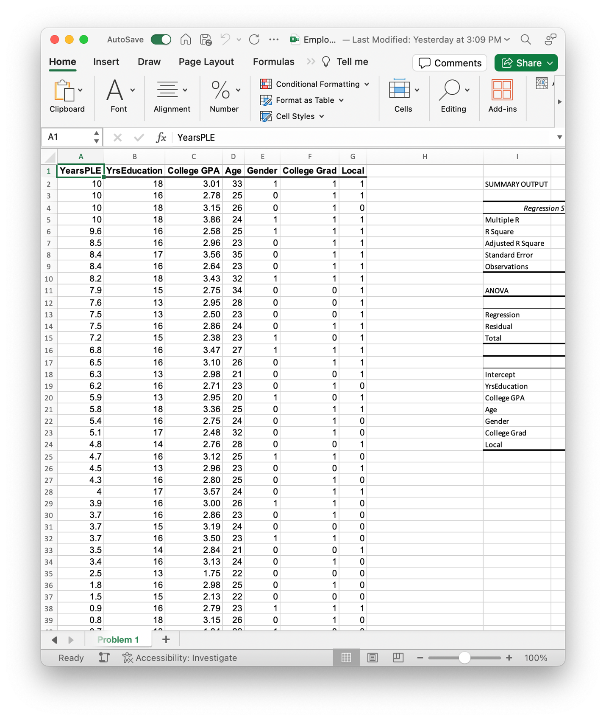

- Please run multiple linear regression and attach the regression result Table.

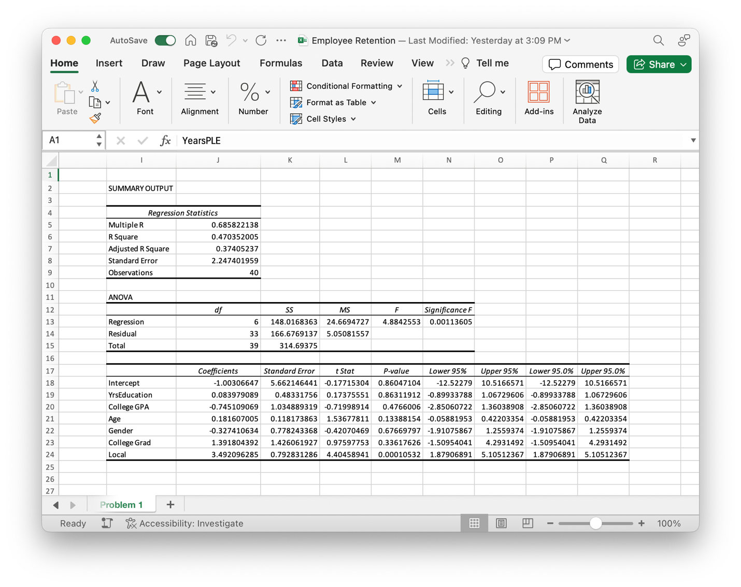
- Based on the regression results, please discuss the determinants (either positive or negative) for employee retention (measured by YearsPLE).
YrsEducation: Positive coefficient, 0.083979089, but p-value, 0.863119116, is insignificant. Suggesting the coefficient is unreliable.
College GPA: Negative coefficient, -0.745109069, but p-value, 0.476600602, is insignificant. Suggesting the coefficient is unreliable.
Age: Positive coefficient, 0.181607005, but p-value, 0.13388154, is insignificant. Suggesting the coefficient is unreliable.
Gender: Negative coefficient, -0.327410634, but p-value, 0.676697966, is insignificant. Suggesting the coefficient is unreliable.
College Grad: Positive coefficient, 1.391804392, but p-value, 0.336176258, is insignificant. Suggesting the coefficient is unreliable.
Local Positive coefficient, 3.492096285, and p-value, 0.000105319, is significant. Suggesting the coefficient is reliable.
- Please discuss the insights based on your findings in Step (3).
The value of R² indicates that 47% of the variation in the dependent value is explained by local variable and being local is a factor associated with longer employee retention.
Problem 2 (6 points):

Please find the EXCEL file named “Engines,” and then please use a regression model to fit the relationship between sample and production time. Please:
- List your regression model
  - Logarithmic
  - Polynomial
  - Power
- Attach a screenshot of the scatter plot of these two variables (sample and production time) and the trend line of your regression.
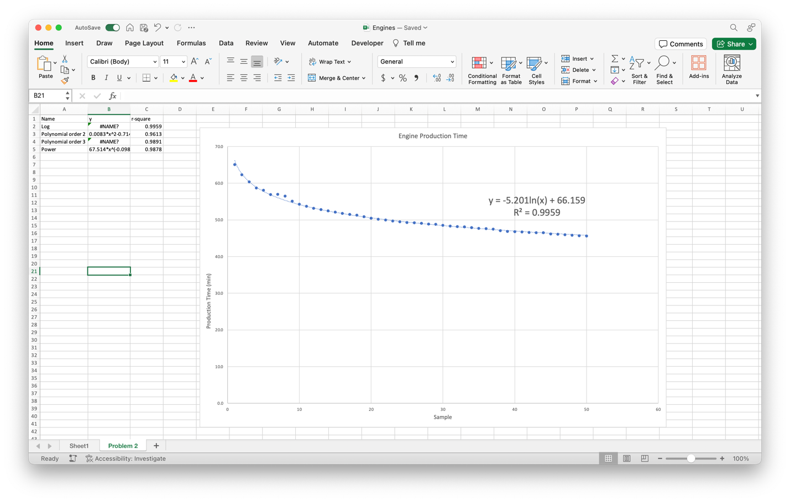
- How about your model fit? Please provide some evidence.
Out of the models, the Logarithmic has the largest R², 0.9959. Therefore, it is significant.
- Please discuss the insights based on your findings in Steps (2) and (3). What do you think about the relationship of these two variables (sample and production time)
The scatterplot displays a negative correlation, therefore, there’s a significant relationship of the two variables, Sample and Production Time, with the R² is 0.9959.

Problem 3 (6 points):

Please find the EXCEL file named “Students,” and then cluster these students based on your selected features.
- Please the features you selected.
- Math Score
- Reading Score
- Parental Level of Education
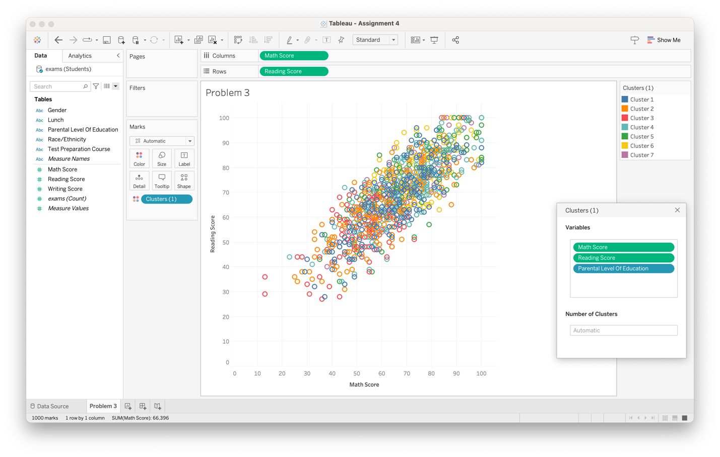
- Please use statistics to show why your selected features are appropriate.
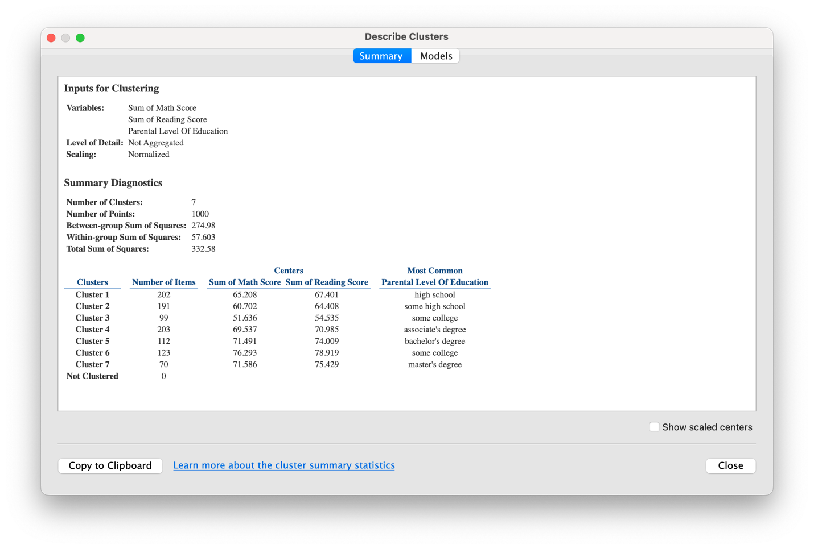
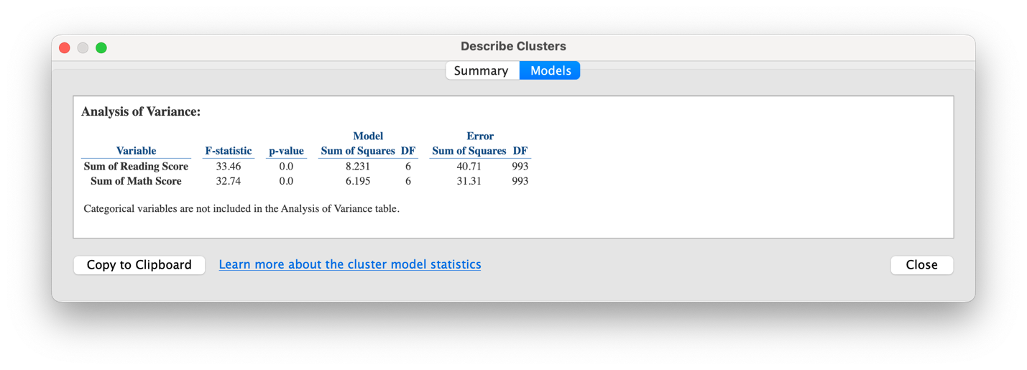
- Please discuss how many groups you clustered and for each group (cluster), what are the features of the students?
There are 7 groups of clusters , each group is a sum of math and reading score with a different parental level of education. Group 1 has the lowest average score of math and reading with most parents have high school or some high school education. While group 7 has the highest average score of math and reading and most parents who have master’s degrees. There’s a correlation between score and parental’s level of education, students with parents who have higher level of education have better score of math and reading.

